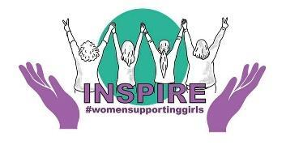 |  |  |  | REFERRAL FORM
The Inspire Project
referrals@motherwellcheshirecio.com
 |  |  |  | To eradicate health inequalities and amplify voices for young women in Cheshire and beyond with the aim of improving physical and mental wellbeing outcomes.
A |  | Referrer to complete this section, AND section B if you are referring someone to our services
What organisation
do you work for?
 |  | What is your full name?
 |  | Should we need to speak to you about your referral, please provide your contact details: |  | Email address:
 |  |  |  | Contact number:
 |  | Is the person below aware that you are making this referral? |  |  |  |  |  | ☐Yes  ☐No
B |  | Please provide as much information in this section as possible
 |  | Name:
 |  | Date of birth:
 |  | Address:
 |  | Young person’s phone number:
 |  | Email address:
 |  | Preferred method to contact: |  | ☐Phone  ☐Email  ☐Address |  |  |  |  |  | Date form completed:
 |  |  |  |  |  |  |  |  |  | ………………………….
 |  | School or college currently attended |  | - Brine Leas  - Malbank  - Ruskin High School  - Shavington Academy  - Sir William Stannier  - The Oaks  - UTC Crewe  Other……………………………………………………
Year group at time of referral: |  |  |  |  |  |  | Year 9 Year 11  Year 10 Post 16
 |  | Details of situation and concerns or risks arising:
☐ I confirm that I give my consent or have permission to share the information provided on the referral
form, for the purposes of accessing Motherwell Cheshire services.
☐ I (your client) understands that the information collected on this referral form will be stored by
Motherwell Cheshire CIO in accordance with the Charity’s policies and may be used for impact evaluation
and funders reports.
Please send this referral via email to referrals@motherwellcheshirecio.com. Please call 01606 557666 if you would like to discuss with our referral team. Once we receive the referral, we will get in touch within 5 working days to acknowledge receipt of the form and discuss the next steps with the person being referred.

